Weapon 2

Hammer and Trigger Mechanism

G. Rubber-band-powered Hammer Weapon
The hammer subsystem serves as one of the primary offensive and defensive components within the rover’s weapon system. Its main purpose is to deliver a rapid, high-impact strike capable of damaging, dislodging, or destabilizing opposing rovers during close-range encounters. In addition to its striking capability, the hammer also acts as a physical barrier that can absorb and deflect incoming contact forces, providing dual functionality in both attack and protection. In the final design, energy storage is achieved using tensioned rubber bands rather than coil springs, resulting in a simpler, more efficient, and more reliable weapon mechanism.

Structural Design
The hammer subsystem consists of four main components: the hammer head, the cylindrical shaft, the rubber band retaining ring, and the pivot base.
The hammer head (see Appendix C3) features a rectangular hollow-body geometry with a reinforced front surface that houses a pyramidal spike insert (see Appendix C4). The hollow side sections reduce mass while preserving a high moment of inertia, enabling faster rotational acceleration during activation. The pyramidal spike focuses impact energy onto a small contact area, increasing localized force during collisions.
The hammer shaft (see Appendix C2) is a hollow cylindrical tube that connects the head to the pivot joint. The hollow geometry minimizes weight while maintaining stiffness under repeated impact loads. A transverse bore near the base of the shaft allows a pivot rod to pass through the shaft and the mounting plates of the pivot base.
The pivot base (see Appendix C6) is a 3D printed structure that was securely bonded to the rover’s upper chassis. It includes two parallel vertical plates with aligned circular holes that support the pivot rod. When assembled, the shaft rotates freely around this rod, allowing the hammer to swing along a fixed arc during release.
A custom 3D printed rubber band retaining ring (see Appendix C5) slides onto the hammer shaft and includes a curved lip designed to seat the rubber bands securely. The ring prevents the bands from sliding along the shaft and ensures consistent tension direction when the hammer is cocked. The retaining ring also functions as the primary mechanical interface for the servo’s metal release rod, which locks the hammer into position during arming. The complete assembly used on the rover is shown in Appendix C1.

Actuation and Triggering Mechanism
The hammer subsystem operates using a rubber-band-powered actuation method combined with a servo-controlled release latch. This system stores elastic potential energy in tensioned rubber bands and releases it rapidly to produce a high-speed, high-impact swing.
A 3D printed hook mounted on the front of the rover chassis anchors one end of the rubber bands, while the opposite end loops around the retaining ring on the hammer shaft. Pulling the hammer backward stretches the rubber bands between these two points, storing the potential energy that powers the strike.
To hold the hammer in its cocked position, the team employed an MG996R high-torque servo motor fitted with a small metal rod attached to the servo horn. When the hammer is pulled back, this rod rotates behind the retaining ring, preventing the hammer from releasing prematurely. Once the user presses the fire button on the custom PCB controller, the programmed servo routine rotates the rod out of the ring’s path. This action disengages the latch, allowing the tensioned rubber bands to accelerate the hammer forward.
Compared to a fully motor-driven approach, the rubber-band-and-latch system significantly reduces electrical power consumption and mechanical complexity. The servo is active only during the locking and release phases, while the rubber bands provide the striking force. This results in faster actuation, lower current draw, and improved reliability during extended operation.

.IEEE conference templates contain guidance text for composing and formatting conference papers. Please ensure that all template text is removed from your conference paper prior to submission to the conference. Failure to remove template text from your paper may result in your paper not being publish

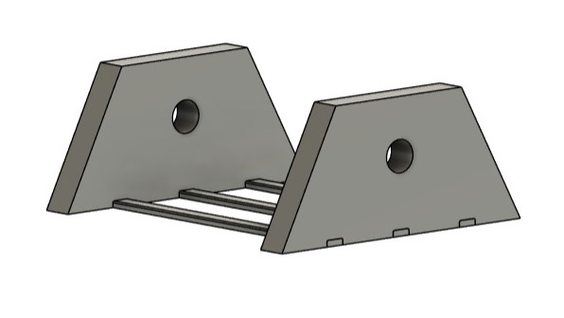
Fig. C6. Pivot base used to mount the hammer to the rover chassis. The two vertical plates contain aligned holes for the pivot rod, creating the hinge joint that allows the hammer to swing when released.

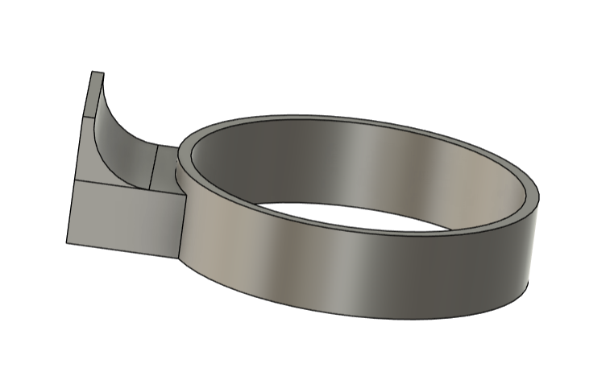
Fig. C5. Rubber band retaining ring that slides onto the hammer shaft. The curved lip secures the rubber bands during tensioning and provides the surface that interfaces with the servo release rod.

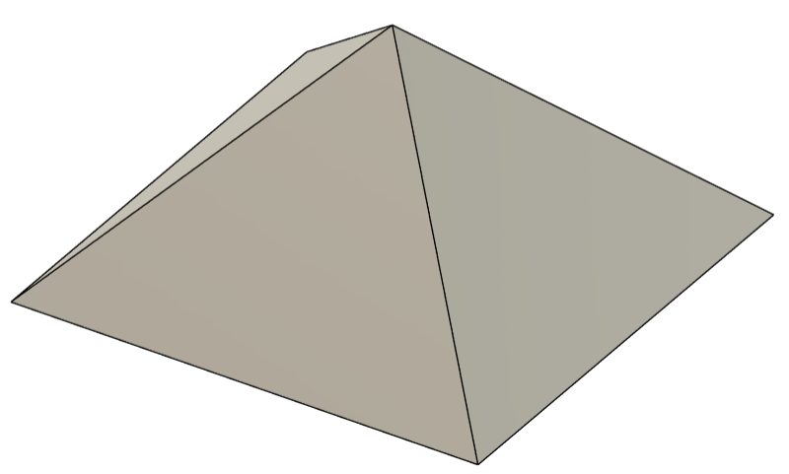
Fig. C4. Pyramidal spike insert used to focus kinetic energy onto a small impact region. This geometry increases localized damage and improves the hammer’s striking effectiveness.
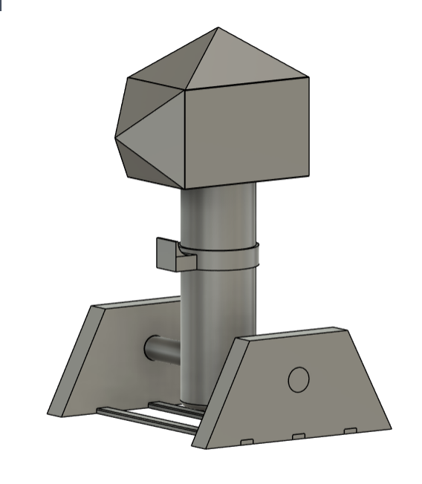
Fig. C1. Complete hammer assembly showing the final design used on the rover. The model includes the hammer head, cylindrical shaft, rubber band retaining ring, and the pivot base used to mount the mechanism to the chassis.

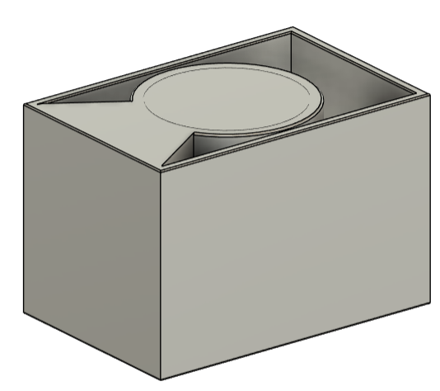
Fig. C3. Rectangular hammer head with hollow side geometry and an internal cavity designed to reduce mass. The reinforced front face provides a mounting surface for the pyramidal spike insert and concentrates impact forces at the point of contact.
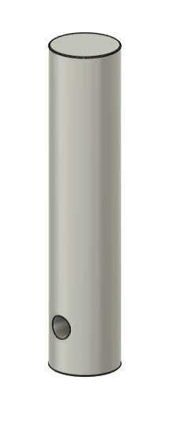
Fig. C2. Hammer shaft modeled as a hollow cylindrical tube to reduce weight while maintaining structural stiffness. The transverse bore near the base houses the pivot rod that allows rotational motion during release.

